**Campaign Sponsors:**

The Alzheimer’s Association

**Volunteer Advertising Agency:**

VML

**BACKGROUND:**

Nearly 7 million Americans are living with Alzheimer’s. By 2050, this number is projected to rise to nearly 13 million. In 2021, Alzheimer’s disease was the fifth-leading cause of death among people 65 years and older. Communities of color are disproportionately at risk for developing Alzheimer’s and other dementias. Additionally, there is evidence that missed or delayed diagnoses are more common among Black & Hispanic adults than among older White adults.

While there is no cure for Alzheimer’s currently, there are new treatments that can slow progression of the disease. These treatments are only available to individuals in the earliest stages of the disease – making early detection and diagnosis critically important. Early detection and diagnosis have many benefits and are the first steps towards creating a plan of action.

**CAMPAIGN OBJECTIVE:**

Get individuals diagnosed with Alzheimer’s earlier, by educating Pre-Care Partners on the differences between signs of Alzheimer’s and typical age-related changes, and the benefits of an early diagnosis. Then, encourage them to have a conversation about the disease with their loved ones, armed with the power of knowledge and understanding.

**TARGET AUDIENCE:**

* ***Primary***:Pre-Care Partners – Adults 34-54 with a parent or spouse 55 and older who will likely be the first to notice changes in their older loved one and likely to become the caregivers if their loved ones should be diagnosed with Alzheimer’s disease.
* ***Secondary***: Those at risk for developing Alzheimer’s (individuals 55+).

**CALL TO ACTION:**

Learn the warning signs at 10signs.org (10señales.org in Spanish).

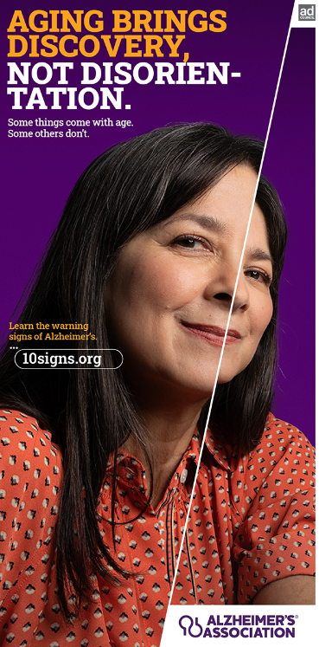

**DID YOU KNOW?**

* Hispanic and Latino Americans are **1.5** times more likely than non-Hispanic Whites to develop Alzheimer’s and othe dementias.
* Black Americans are about **2** times more likely than White Americans to develop the disease.